:
We read about Dr. Martin Luther king this week. We discussed that biographies are nonfiction writing. We know that when an author writes in nonfiction their purpose is to inform the reader. We also discussed verbs in the present, future and past tense.
Please remind your child to bring their AR book daily, as we should be getting close to beginning our cereal boxes. We will have a day in class next week to work on them. Please ask your child how many beads they have. I sure hope we can all have one before Christmas.
The cereal boxes are due December 13th. The instructions for the new project will come home after Christmas break, but will not be due until the end of February.
We will finish up the phases of the moon.
We finished Junior Achievement. Thank you Julie Degen! We are moving on to the next region of the US. You will see maps coming home the first week of December.





- No School Thursday & Friday November 25th and 26th Happy Thanksgiving!!

- Please remember to send back your early dismissal forms asap. We can never be sure when that bad weather will arrive. I still need a few!!!!!!!

- Please bring items for the food drive. We are collecting noodle and rice meals. THANK YOU

- Book Orders are due Friday December 3rd!

- Please bring back your guided reading books, or $5.00 by Monday!!

- I will be leaving school on December 14th, as I will have my baby that week. LuAnne Thompson will be the substitute.

Longfellow: 996-3248
Home: 605-928-7274
E-Mail: kristina.borgan@k12.sd.us
Web Page http://kh075.k12.sd.us


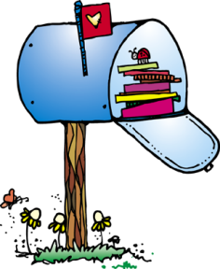


Jordan Dierks
Star of the week



